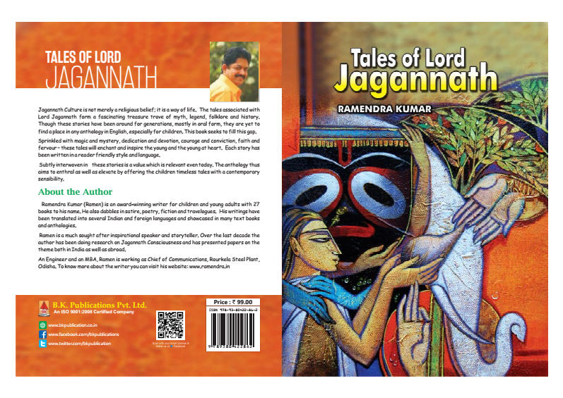

**Jagannath Culture: A Way of Life**

Jagannath Culture offers an elevating and enchanting collage of philosophy, literature, wisdom and lots more. It covers the entire gamut from timeless tales to ageless credos. It provides to the young generation a glimpse of our rich and glorious heritage as well as paradigms of value.

To commemorate the Rath Yatra, Learning and Creativity presents **10 Tales of Lord Jagannath** written by Ramendra Kumar.

Ramendra Kumar has been doing research on Jagannath Culture for more than a decade. What makes this book unique is that though these tales have been around for centuries in oral form, they have not found a place in any anthology for children in English. Besides, subtly interwoven in each of these stories is a value which is relevant even today. The anthology thus aims to enthrall as well as elevate by offering the children eternal tales with a contemporary sensibility.

Jagannath Culture is not merely a religious belief, it is a way of life. Given below are a few nuggets which illustrate what makes Jagannath Culture an all encompassing consciousness:

* The three images of Lord Jagannath, Goddess Subhadra and Lord Balabhadra represent the three colours of humankind – black, yellow and white. Can there be a more evocative illustration of the concept of *Vasudhaiv Kutumbakam* or ‘world is one family’.

Today when planet earth is being rocked by violence and intolerance the concept of *Vasudhaiv Kutumbakam*, if internalised, can provide the healing touch.

* In temples the Lord is usually seen with his wife/companion. The Jagannath Temple is the only temple in the world where the Lord appears with his brother Lord Balabhadra and sister Goddess Subhadra. Can there be a better example of family values?

In modern India the joint family system is slowly breaking up and the nuclear family is becoming more and more the norm. This is leading to several social and psychological problems. By embracing the ethos of family values our society can once again usher in the era of brotherhood and peace for which it was famous.

* The images are made of wood. They signify commitment to the environment.

Nature is fast becoming the first casualty in man’s quest for prosperity. Man should draw inspiration from the Jagannath Culture and go back to preserving and nurturing nature.

* All the Gods and Goddesses are ensconced in their chambers waiting for their devotees to go to them for *darshan*. Lord Jagannath is the only Lord who, along with his siblings, comes out of his abode and reaches out to his devotee during the *Rath Yatra* which is also called the *Patitapavan Yatra*. Can there be a more eloquent example of love, affection and bonding?

It is often found and modern society that today’s leaders rather than reaching out to the people prefer to be in their cocoons of arrogance and power. As a result they get alienated from those whom they are supposed to serve. *Rath Yatra*teaches us the importance of achieving a connect between different layers of society.

* As per legend, Lord Jagannath was originally worshipped in the form of Neelamadhav by a tribal known as Visvavasu. A class of *sevaks*known as Daitapatis, which has a tribal lineage, even now renders important services in the temple. The custom of involving tribals in religious ceremonies in a Vaishnavite temple is once again a phenomenon unique to the temple of Lord Jagannath.

Tribals have long been marginalised by the society. However, the Jagannath Culture doesn’t believe in excluding anyone, rather it encourages the participation of one and all.

* Lord Jagannath’s reach is beyond religion, faith and doctrine. His disciples include Adiguru, Sankaracharya, Sikh Guru, Nanak; Vaishnavite, Sri Chaitanya Deva; Ram Bhakta, Goswami Tulasi Das; devotee of Ganesh, Ganapati Bhatta; Muslim devotees, Kabir and Bhakta Salbeg; devotees such as Dasia Bauri, Mania Das and many others who belonged to lower caste and the Christian disciple, Captain Beat, etc.

The Jagannath Culture crosses the boundaries of caste, creed, religion and race to embrace the entire humankind.

* An example of how the Jagannath Culture epitomizes a classless and casteless society is in the serving of Mahaprasad. Any one belonging to any caste can take the Mahaprasad or *Kaivalya* from the same plate.

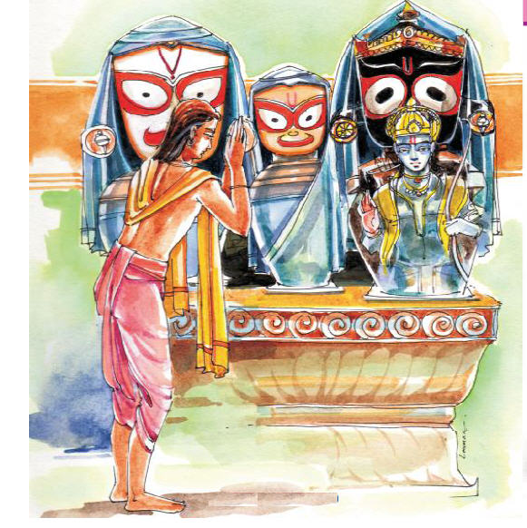

The three images of Lord Jagannath, Goddess Subhadra and Lord Balabhadra represent the three colours of humankind

# Tales of Lord Jagannath: In Search of the Divine

King Indradyumna epitomises faith, devotion, commitment and a never say die spirit. In spite of all odds he never wavered from its resolve and ultimately succeeded in his mission. The present day child should be exposed to these time cherished values so that she grows up into an individual who believes in the power of the mind and the strength of the soul.

## **Lord Jagannath Tales 1**

King Indradyumna, was a wise and brave King who lived hundreds of years ago.  He was a fervent devotee of Vishnu and spent much of his time in the worship of the Lord.

One night, when he was lost in his dreams, he had a strange vision. Lord Vishnu himself appeared before his ardent devotee and said, “Somewhere in the region of Kalinga, not far from Puri, lies an object which radiates my presence. The time has come to reveal this phenomenon to the entire world. I have chosen you to be the medium for this mission.”

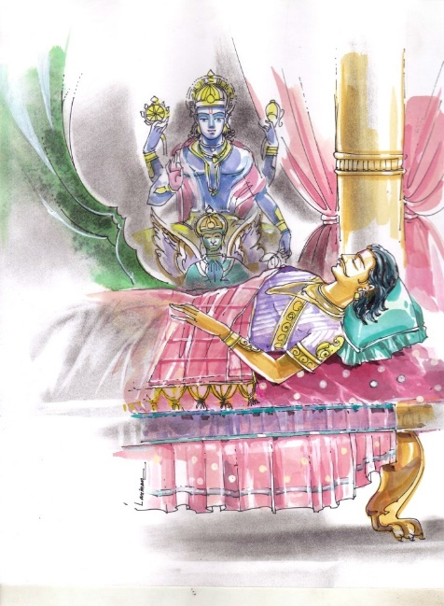

One night, when he was lost in his dreams, he had a strange vision.

With these words Lord Vishnu disappeared from the King’s dream. King Indradyumna woke up with an overwhelming feeling of joy, excitement and also apprehension. He was delighted that the Lord himself had blessed him and declared that he was the Chosen One. At the same time he was filled with a great deal of anxiety. The Lord had not given him any idea how and where he could find the divine object.

After pondering over the issue for quite some time he sent four of his courtiers  in four different directions. The King had carefully chosen only those men who were prudent and had a good knowledge of religion and spirituality. The one who headed to the east was the young Vidyapati, the brightest of them all.

After travelling quite some distance, Vidyapati found he had lost his way in a forest. As he desperately looked for help he heard the sound of girls talking. He rushed ahead to find a group of young maidens coming his way. Apparently they had gone to take a bath in the nearby lake and were returning.

Seeing him the girls stopped in surprise and looked at him with suspicion.

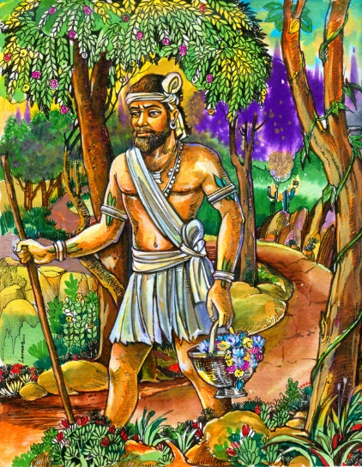 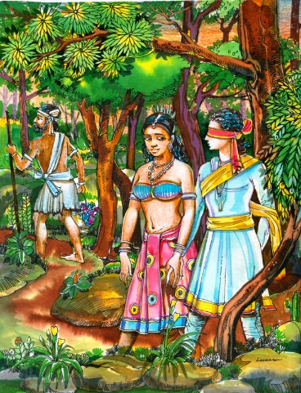

After travelling quite some distance, “Lalita, can I too have the privilege of paying obeisance to the Vidyapati found he had lost his way in a forest. divine entity?”

“My name is Vidyapati and I am the emissary of King Indradyumna. I got lost in the forest and have been roaming around for God knows how long, seeking a way out,” he said.

The girl who was in the lead smiled and replied, “I am Lalita, the daughter of the Savara Chieftain, the brave and noble Visvavasu. These are my friends. Please come with us. I shall take you to my father who will take care of you.”

The beautiful and comely Lalita led Vidyapati to her abode and introduced him to the tribal chief. Visvavasu welcomed the guest with open arms and invited Vidyapati to enjoy the hospitality of the tribals for as long as he wanted. The young emissary gratefully accepted the invitation.

Visvavasu was a gracious host and Vidyapati started enjoying his stay. The chieftain was also a devotee of Lord Vishnu. He had rarely got an opportunity to discuss with anyone deeper aspects of spirituality and religion. In Vidyapati, Visvavasu found an ideal companion to confer and debate. In the meanwhile the tribal chief also noticed that his pretty daughter was showing a rather keen interest in the handsome guest.

After getting confirmation of Lalita’s feelings, Visvavasu sought his guest’s opinion. “My dear Vidyapati, over the last few days you have become almost like a family member. My entire tribe has come to love and respect you. Lalita, I have found, harbours feelings much stronger than affection for you and my old and experienced eyes tell me her sentiments too are reciprocated. I seek your consent for your union with my dearest daughter. What is your response?”

“Respected Sir, all I can say is I am humbled at your proposal. Marrying the enchanting and talented Lalita would make me truly happy. I wish to express my grateful thanks to you for considering me suitable enough for your gifted and charming daughter.”

Vidyapati and Lalita were married and the celebrations continued for many days and nights. Vidyapati settled down with his new bride in her home.

As days passed by Vidyapati was intrigued by a routine which his father-in-law seemed to observe every day – come rain, sun or shine.  Visvavasu would leave home before sunrise with a handful of flowers and return home after an hour.

One day Vidyapati couldn’t resist asking Lalita, “Where does your father go every morning? I have been observing that he doesn’t miss a single day.”

Lalita tried to avoid answering but when he persisted she replied, “My father’s destination is a cave deep in the forest. Inside the cave is a divine object which is sacred to our family. My father goes to the cave every morning to pay obeisance to the object.”

Hearing his wife’s reply Vidyapati experienced a feeling of excitement and anticipation. ‘Was he nearing the end of his mission? Was the object inside the cave the divine presence he had been sent to find?’

“Lalita, can I too have the privilege of paying obeisance to the divine entity?”

“I’ll have to ask father because as per our family tradition only the eldest son is allowed to worship the object.”

“Please, do seek his permission. I am sure he will understand my desire to pay obeisance to your family deity.”

Lalita went and told her father Vidyapati’s earnest request. At first Visvavasu rejected the idea outright. “We can’t break an age old family tradition. Our ancestors will never forgive me.”

However, Lalita too wasn’t someone who would give up easily. She continued to persist and finally Visvavasu had to yield to the demands of his beloved child.

“Okay, you can take your husband to the cave but on one condition – he has to be led blindfold.”

The next day, before sunrise, Vidyapati and Lalita started on their journey. The blindfolded Vidyapati, without Lalita realizing it, started dropping mustard seeds along the path they were taking. Once the couple entered the cave Lalita removed the blindfold. Vidyapati was dazzled by a bluish golden light that seemed to be emanating from a stone casket. It had no clear form but its sheer beauty, grandeur and brilliance convinced Vidyapati that right in front of him was the very purpose of his mission. He had finally found the presence which Lord Indradyumna had been told about by none other than Lord Vishnu himself. Vidyapati was barely able to conceal his thrill and joy from his wife.

They returned in the same manner with Vidyapati blindfolded and guided by Lalita. After a few days Vidyapati told Lalita, “I have been away from home for a very long time. My parents would be worried. I shall go home, inform them about our marriage. I’ll then come back and take you so that together we can seek their blessings.

The very next day Vidyapati left before dawn. The mustard seeds he had strewn had sprouted and the plants helped him find his way to the cave. He entered the cave and lifted the sacred casket and hurried to Puri, to his King.

Vidyapati quickly recounted to the King the entire story right from losing his way in the forest to finding the divine object.

The wise King immediately realized that Vidyapati had brought the very entity Lord Vishnu had told him about. However, one question remained. How was this divine presence to be preserved?

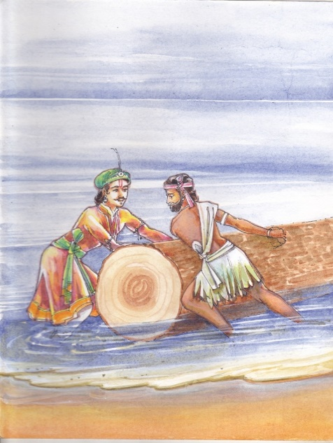 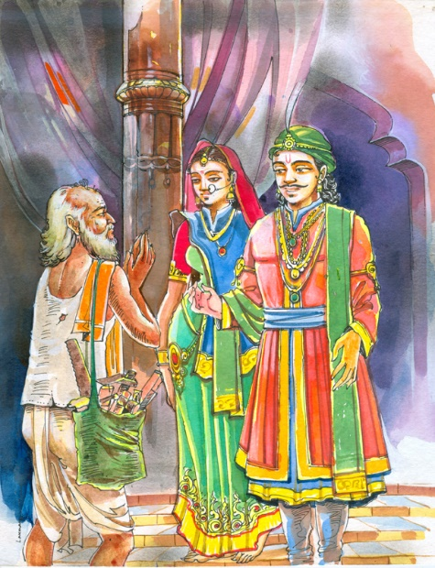

Right in front of their eyes was an “I should be given an exclusive workshop to work all alone. “

impressive looking log floating on the waves.

That night once again Indradyumna had a dream. In the dream he was asked to go to the seashore where he would find a log floating. This divine form was to be placed in this log.

The next morning the King, along with Vidyapati and some of his men, rushed to the beach. Right in front of their eyes was an impressive looking log floating on the waves. The King’s joy knew no bounds. Finally he was nearing his mission. He immediately ordered his men to bring the log to the shore. The log was tied securely to the boat and the men tried to bring it ashore. But the log didn’t shift an inch. More number of men and boats were brought in but the result was the same. The entire day was spent in this pursuit but the log could not be moved. The poor King sat on the beach without eating a crumb, just waiting and waiting for his dream to be fulfilled. Finally after sunset as the King sat staring at the dark waters of the sea he had a vision. He saw Visvavasu sitting in front of an empty cave in state of shock, without food or sleep. Beside him, shedding tears of guilt and repentance was his daughter.

Next morning the King accompanied by Vidyapati rushed to meet Visvavasu. On reaching the Savara chief’s abode Indradyumna apologized to Visvavasu for the conduct of his emissary. He then told the Chief about how Lord Vishnu had appeared in his dream and given him directions.

“Oh! Savara chief you have been guarding the Lord with great devotion and dedication but now the time has come to share the divine presence with entire humanity. This is Lord’s will.”

The noble Visvavasu reconciled to the situation and came along with the King. The two went straight to the beach and together pulled the log. As the onlookers watched in amazement the  log  floated across the waters like a feather.

Indradyumna and Visvavasu embraced each other and there was huge cheering and celebration all around.

However, King Indradyumna realized that the mission had still not been achieved.  No one knew what would be the exact shape of the deity. Kalinga had many gifted sculptors but they were all experts in carving images out of stone. They had no idea how to make images from wood.

The King waited patiently hoping that this question too would be resolved by his favourite Lord. After sometime an old man appeared before the King.

“Maharaj, I have come to know you are looking for a sculptor who can carve images from wood. Well, I can do that. But I have one condition.”

The King who was naturally delighted to at last meet someone who was ready to take up the challenge asked, “Please tell me.”

“I should be given an exclusive workshop to work all alone. No one should disturb or offer any suggestions or interfere in any manner whatsoever with my work. No one should enter the workshop till I complete my work and come out.”

King Indradyumna agreed immediately. He instinctively felt the old man had been sent by the Lord himself to complete the task.

A spacious hall was converted into a workshop. The sculptor was provided with all the tools and tackles. He immediately locked himself in and started his work.

The King, who had no doubt whatsoever that the sculptor would deliver the best results waited patiently. His queen Gundicha Devi however had her own misgivings.

Every day she would go and press her ear against the door. Only after hearing the sound of implements at work would she return to her chamber. Time went by.  One day however she heard no sound. The entire day she kept moving from door to door and back again, but there was not even the faintest of sounds The next day too total silence was  all she got to hear. Finally the queen lost her patience and forced the door of the workshop open. The old sculptor, who seemed shocked, looked at her for an instant and then disappeared.

He was none other than the divine architect Lord Visvakarma.

King Indradyumna reached the workshop and found that the image of the Lord looked incomplete. He was very much upset that he had failed his Lord. Just then he heard a divine voice, the voice of Lord Vishnu himself. “Oh king, you need not be saddened or distressed. You worship me in this form itself. My incomplete self represents the state of mankind – its incompleteness.”

The King was elated and so was queen Gundicha who had been cursing herself for her impatience.

The divine presence Vidyapati had brought was placed inside the Navipadma – the lotus-like navel of the deity. The deity was enshrined and the regular worship began – a worship which continues till this day.

## **Lord Jagannath Tales 2**

Mania Das was a poor man of weaver caste who lost his family all of a sudden. As a result of this brutal tragedy he suffered complete detachment from all worldly things and sought refuge at the lotus feet of Lord Jagannath.

‘After losing everything that I had, I have no desires left. All I want to do is to devote every moment of my life to singing the praise of my Lord,’ he kept repeating to himself as he walked towards the Jagannath Temple at Puri.

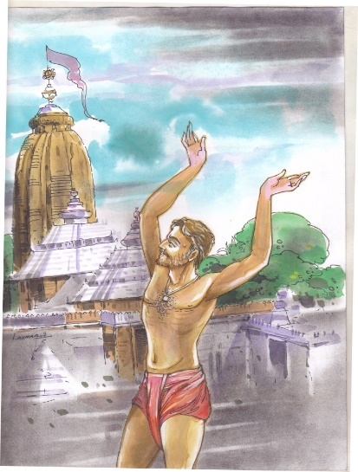 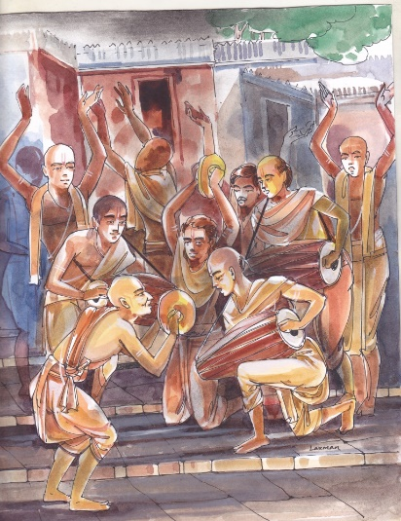

All I want to do is to devote every moment I also want that Mania be given complete freedom to

of my life to singing the praise of my Lord sing, dance and celebrate as per his free will in Sri

Jagmohan.

Clad in a loin cloth he entered the Sri Mandir. There, in an area called Sri Jagmohan, Mania began to sing and dance in complete abandon. His passionate chanting and dancing irritated and angered the Pandas who were chanting the Puranas.

“Hey you filthy outcaste! How dare you enter the Lord’s chamber and indulge in this lunatic behaviour? Can’t you see you are disturbing us and interfering in the sacred rituals we are performing for the supreme Lord of the Universe?” the Pandas shouted and threw him out of the temple.

Bitterly hurt at this treatment he stood outside the Sri Mandir refusing to eat or drink anything and even declining the Mahaprasad.

Lord Jagannath was deeply moved by the plight of his passionate devotee. He appeared before the Raja of Puri in a dream.

“O’ King, I am deeply disturbed by what is happening in my temple. My faithful devotees are being ill treated and their attachment towards me is being scorned.”

The Lord then went on to narrate the story of Mania Das to the King.

“O’ King, I want you to give Mania the Mahaprasad and with due respect, escort him inside the temple. I also want that Mania be given complete freedom to sing, dance and celebrate as per his free will in Sri Jagmohan. Remember that to me the pure and pristine devotion of devotees that comes straight from the heart is far more important than rituals which are performed mechanically.”

The Raja of Puri obeyed the Lord’s wishes and the tradition of devotees chanting, dancing and celebrating with gay abandon in Sri Jagmohan continues till today.

# Tales of Lord Jagannath: The Story of Dasia Bauri

This story illustrates the power of faith. One night Dasia and his family had nothing to eat. Lord Jagannath appeared at the gate in disguise asking for food.

## **Lord Jagannath Tales 3**

Dasia Bauri was an untouchable who lived in abject poverty.  He was great devotee of Lord Jagannath.  Once, people from his village were going to the Jagannath Temple at Puri. Since Dasia was too poor to go along with them and had nothing else to offer to his Lord, he gave them a coconut. He requested them to offer the coconut to Lord Jagannath at Aruna Stamba outside the main gate. The villagers laughed at his suggestion but acceded to his request.

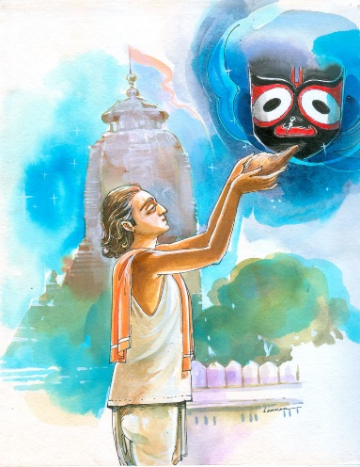 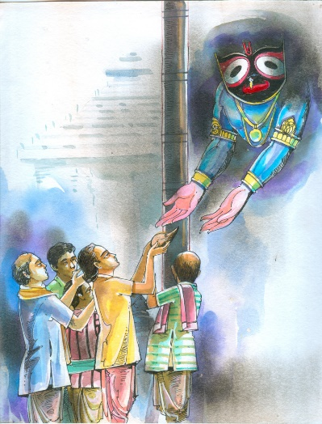

He requested them to offer Lord was accepting his loyal devotee’s affection

the coconut to Lord Jagannath

Next day there were amazed to find only the shell of the coconut exactly at the same spot where they had left the offering. This proved beyond doubt that the Lord had received the offering given by  Dasia.

After that every year Dasia Bauri would send a basket full of ripe mangoes for Lord Jagannath. The next day the priests would discover the kernels at the altar, a sure sign that the Lord was accepting his loyal devotee’s affection.

One night Dasia and his family had nothing to eat. Lord Jagannath appeared at the gate in disguise asking for food.  Dasia’s wife Malati could not find even a morsel to feed the hungry guest. Finally she could manage a grain of rice and offered it to the visitor.  The guest accepted her offering and declaring that he was satisfied left.

That night the King of Puri had a dream. It was revealed to him that Dasia Bauri and his family were all  going to sleep hungry because there was not a single crumb of food in the house. The King arranged for food to be sent every day to Dasia’s home.

To this day, just after the bhog is offered to the divine trinity, the first offering is sent to Dasia Bauri.

The King arranged for food to be sent every day to Dasia’s home.

# Tales of Lord Jagannath: The Account of Ganapati Bhatta

The story behind the appearance of Lord Jagannath, Lord Balabhadra and Goddess Subhadra in Ganapati Vesha at the Snana Mandap.

## **Lord Jagannath Tales 4**

Ganapati Bhatta was an ardent disciple of Ganesha. Once he traveled all the way from Maharashtra to witness the Snana Yatra of Lord Jagannath. The Snana Yatra takes place on the full-moon day of Jyeshtha.

When Ganapati Bhatta arrived at the Snana Mandapa, he did not find an elephant head on Lord Jagannath. He was terribly disappointed since he could not behold his favourite God.

Lord Jagannath could gauge the feelings of the devotee. Disguised as a Brahman, the Lord met Ganpati Bhatta as he was leaving Puri in a state of dejection. The Lord persuaded him to visit the Snana Mandap in the evening.  
When Ganpati Bhatta reached there he was ecstatic to find Lord Jagannath with the head of an elephant looking exactly like Lord Ganesha.

Since that day each year on the auspicious occasion of Deva Snana Poornima Lord Jagannath, Lord Balabhadra and Goddess Subhadra appear in Ganapati Vesha after taking bath at the Snana Mandap.

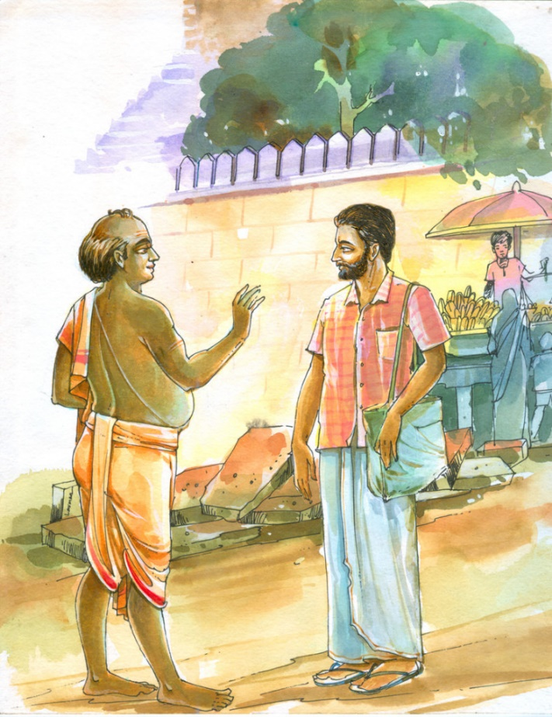

Disguised as a Brahman, the Lord met Ganapati Bhatta as he was leaving Puri in a state of dejection.

# The Saga of Salbeg

## **Lord Jagannath Tales 5**

Salbeg’s mother was a Brahman widow. A Muslim soldier married her forcefully. Salbeg grew up to become a soldier like his father and joined Aurangzeb’s army.

Once he was severely injured in battle. His mother nursed him while continuously chanting the name of Lord Jagannath.

After regaining his health, Salbeg became an ardent devotee of Lord Jagannath and began composing and singing bhajans in praise of the Lord. He settled down in Vrindavan.

Once desirous of seeking the blessings of his Lord he went to the temple at Puri but was not allowed to enter since he was a Muslim. Sometime later he again left for Puri to catch a glimpse of his Lord when he came out on the streets during the annual Rath Yatra. Salbeg fell ill on the way and prayed to the Lord to wait for him so that he could get his divine darshan. The chariot of the Lord waited till Salbeg arrived. Only after the great devotee got the darshan of his master and touched the ropes of the chariot did it move.

Even to this day the chariot stops at exactly the same point where it had halted for Bhakta Salbeg long ago. Another tribute to the great disciple’s devotion is the fact that the bhajans composed by Bhakta Salbeg are an integral part of the Rath Yatra celebrations.

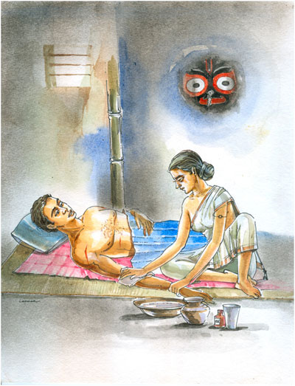 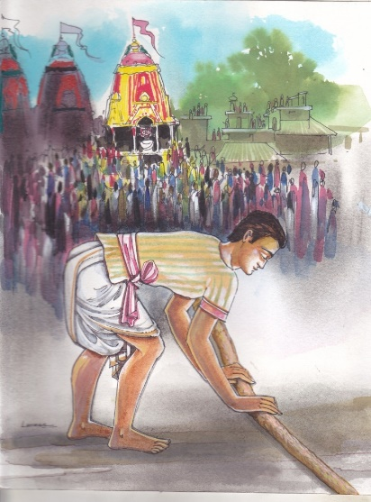

His mother nursed him while continuously Only after the great devotee got the darshan of his

master and touched the ropes of the chariot did it move. chanting the name of Lord Jagannath

# Tales of Lord Jagannath: The Anecdote of Arjun Mishra

This interesting anecdote brings to life a simple truth: never, ever doubt the word of the Lord. Good and bad happen with his will. He rewards patience and faith and as long as these virtues are there the end will be a fulfilling one.

## **Lord Jagannath Tales 6**

Arjun Mishra was a devout person who spent much of his time reading the Gita.

Arjun Mishra was a devout person who spent much of his time reading the Gita. He was so busy in his devotional pursuits that often he would not bother to even go out and earn a living.

One evening his wife told him, “You keep yourself occupied in reading *Gita*and forget about your family?”

“What happened?”

“Nothing much. There is not a grain of rice in the house. We will have to sleep hungry. But what is the point in telling you. All you care about is your own interest. Nothing else seems to concern you.”

Arjun Mishra was at that instant reading a passage in which the Lord had assured that the one who turned to him had no cause for despair.

‘I don’t quite believe this line anymore. If it were true why would I have to suffer so much,’ Arjun Mishra murmured and scratching the line went out of the house.

It soon began raining. An hour later there was a knock   and Arjun’s wife opened the door. She was surprised to see two youngsters, one fair and the other dark, entering the house carrying lots of food stuff.  As they placed their burden down, the lady observed a deep scratch on the dark boy’s back.

“What happened to you my child?”

“Mother, your husband got angry with me when I found it difficult to lift this burden and inflicted this on my back.”

The two youth then left the house.

Sometime later Arjun Mishra returned to his house.

“How could you be so cruel towards a tender boy?” demanded his   agitated wife and quickly told him about the two youngsters who had come to deliver the food material.

Arjun Mishra was surprised. He had not sent anyone with food or anything else. In fact he had gone looking for work and because of the rain he had been unable to get anything to do. He had come back with empty hands and a heavy heart, ready to face his wife’s anger.

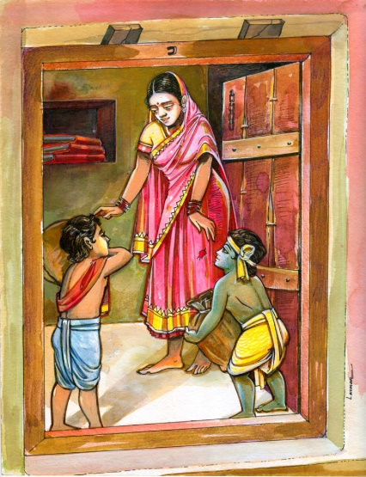 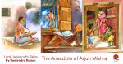

‘I don’t quite believe this line anymore. If it were true why would I have to suffer so much.’

Arjun Mishra sat in silence pondering over this strange mystery. Soon the truth dawned on him.  The two boys were none other Balabhadra and Krishna. What the boys had brought was Mahaprasad.  Bhagvad Gita was as good as the body of Krishna and the scratch he had made on the text was reflected on the back of the Lord.

Stunned Arjun Mishra  bowed his head before the Lord and sought his forgiveness for casting doubts on him and his  word.

# Tales of Lord Jagannath: Experience of Goswami Tulsidas

## **Lord Jagannath Tales 7**

Goswami Tulsidas was a great devotee of Lord Rama. He had heard that Sri Jagannath was an incarnation of Lord Rama. Once he decided to visit the Jagannath Temple to have darshan of his Lord Rama in the incarnation of Lord Jagannath. However, when he entered the sanctum sanctorum of the temple and saw the three deities, he was filled with a sense of disappointment. He could not sense the presence of Rama and came out with a feeling of disenchantment.

As he was descending the steps of the temple known as Baishi Pahacha (Twenty-two Steps), a monkey came jumping and snatched away the shawl which covered his upper body.

Goswami did not know what to do. It was quite dark and he could not see anyone. Suddenly a person appeared, apparently out of nowhere. His face was glowing and his presence seemed divine. He asked the monkey to return the shawl to Goswami. The monkey promptly did so and the creature and Goswami’s benefactor disappeared. Goswami just stood there amazed at the incident. The entire sequence of events had left him searching for answers.

At night Goswami had a dream in which he heard his Lord’s voice. “I am surprised that you came back from the temple disappointed. How did you not feel my presence in the image of Lord Jagannath? He and I are one and the same. The monkey who took your shawl was none other than Hanuman who just wished to give you a little shake-up whereas the man whom the monkey obeyed was none other than Vibhishana.

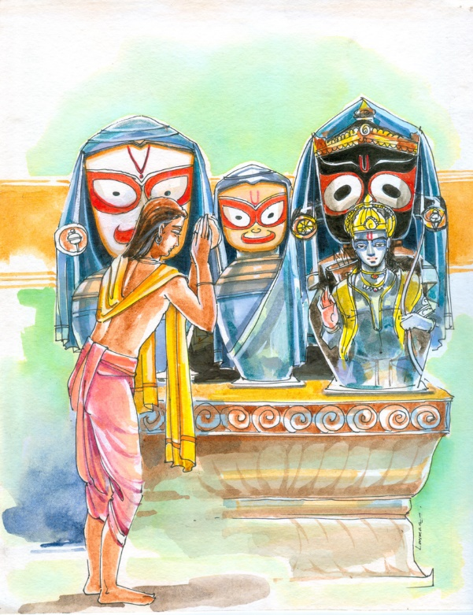

He could not sense the presence of Rama and came out with a feeling of disenchantment.

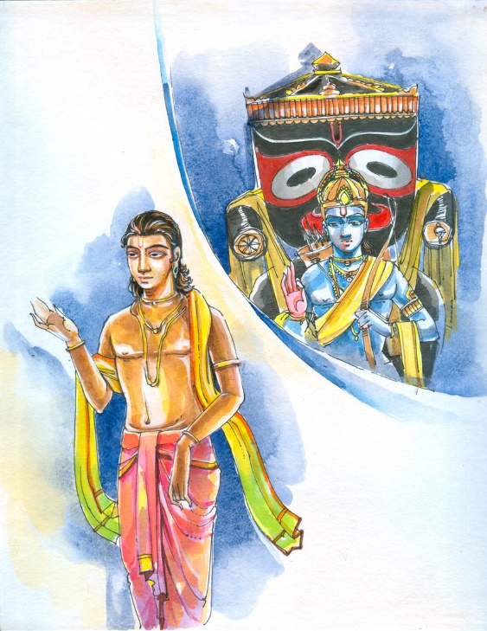

Suddenly a person appeared, apparently out of nowhere

It is believed that even now, every night Vibhishana and Hanuman visit the temple of Lord Jagannath.

Next day Goswami Tulasidas returned to Sri Jagannath temple and sure enough he saw the presence of his Lord in the sanctum sanctorum.

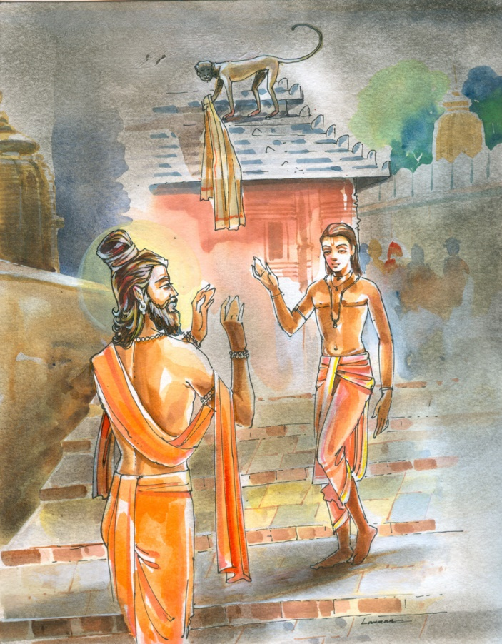

He asked the monkey to return the shawl to Goswami

# Tales of Lord Jagannath: The Legend of Bandhu Mohanty

This riveting legend once again stresses on the importance of loyalty. Though Bandhu is subjected to untold miseries he never loses faith in his friend, Lord Jagannath. His steadfast faithfulness is rewarded when the Lord himself comes to his rescue. It is an ageless tale about a timeless value.

## **Lord Jagannath Tales 8**

In early 16th century, in the town of Jajpur in Odisha, lived a man called Bandhu Mohanty. Though Bandhu was very poor he was an honest and spiritual person. No one knew what his real name was. He had been given the nickname of Bandhu, which means friend, because of his deep attachment to Lord Jagannath. Bandhu considered the Lord as his best friend.

Bandhu lived with his wife, two daughters and a son. He had no property and no means of earning his livelihood. He and his family survived on the alms given by the villagers. However, Bandhu was a contented man, he had no worries. He knew his closest friend, his Lord, was there to take care of him.

Once Jajpur was affected by a severe famine. There was no rain for days. Crops started withering, people had nothing to eat. There was hunger and starvation all around. Many died, others fled in search of food and water. In such a situation Bandhu and his family found it difficult to survive.

Finally, unable to bear the agony of her children, Bandhu’s wife told him, “You keep chanting about the rich, prosperous, kind and generous friend of yours who lives in Puri. Why don’t we go to him instead of starving here?”

Now Bandhu’s wife had no idea that her husband’s friend was none other than the Lord of the Universe, ‘Chaka Aakhi’ himself. She only knew he was someone who was wealthy and powerful and would hopefully not say no to her husband’s appeal for help. After all they were bosom friends.

Bandhu, on the other hand, did not want to trouble his Lord with problems of his own. He felt it would be too selfish a thing to do. So for many days he ignored his wife’s pleas. Finally, when the situation started getting really bad and he could no longer bear to see the pain on the faces of his beloved children, he relented.

The family of five set off for its destination: Puri. After a four day trek they reached the holy land of Lord Jagannath. It was dark. The temple looked magnificent with its glorious structure lit by bright lights. The aura of faith and spirituality made them spell bound. For quite some time all of them held hands and just kept looking at the grandeur of the temple. Hundreds of devotees were thronging the main entrance. The guards or Pratiharis were monitoring the visitors. Bandhu wanted to take his family inside the sanctum sanctorum to have a glimpse of his dearest friend. But he knew they would not be allowed inside by the Pratiharis since they were in rags. Hence, he instructed his family to join him in offering prayers from outside. After paying their obeisance to the Lord, Bandhu, along with his wife and children, left the temple premises.

While looking for a suitable shelter to spend the night, the visitors reached a place called Pejanala. As per custom a huge quantity of rice is cooked in the temple complex for the Mahaprasad or offering for the devotees. The gruel which remains is drained out and deposited at the Pejanala.

Bandhu decided to spend the night there with his family. He brought some rice gruel from the Pejanala which the family ate.

Seeing the condition of the place, which was bare and bereft of even the minimum of comforts, his wife asked, “You keep telling that your friend is wealthy and influential and that he will take care of you whenever you are in need. Yet, instead of taking us to his place why did you get us here? Is it because your friend befriends only the rich like him?”

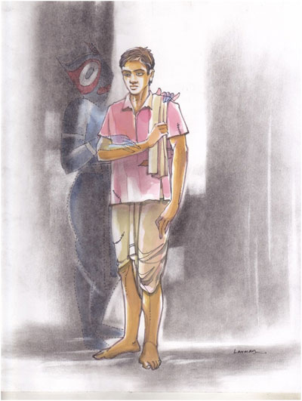

He had been given the nickname of Bandhu, which means friend, because of his deep attachment to Lord Jagannath

Bandhu ignored his wife’s barb and replied quietly, “My friend had too many visitors this evening. We’ll meet him tomorrow when he is free.”

They all went to sleep. Suddenly Bandhu heard someone call his name and woke up with a start. It was pitch dark all around. His family was sleeping peacefully. ‘I must have been dreaming. Or else who would know me here,’ Bandhu muttered to himself and lay down once again.

“Bandhu,” the voice was distinct this time. There was no doubt someone was actually addressing him.

Bandhu got up and looked all around.

He saw a dark skinned Brahman standing with a big plate in his hand.

“Bandhu, your friend has sent Mahaprasad for you and your family. Please take it. He has also assured you that in the morning he will make all arrangements for you,” with these words the dark Brahman handed over the plate.

Bandhu woke up his family and they had the most delicious meal of their lives. As he saw his children eating to their hearts content, savouring every morsel, tears of gratitude welled up in Bandhu’s eyes.

After the meal Bandhu washed the plate and went to give it back to the Brahmin. He searched for him in vain but the Brahmin seemed to have disappeared.Bandhu wrapped the plate in a rag and put it beside him. He then thanked his dear friend for his kindness and happily went to sleep.

The next morning there was a furore in the temple. It was discovered that the big gold thali in which bhog is offered to the Lord was missing. The thali was kept in the Ratna Bhandar, the store house of precious stones, gold ornaments and utensils. Inquiries were made and it was found that the Ratna Bhandar had been locked securely. Then how could the thali have been stolen and who could have committed this dastardly act?

The news of the theft spread all over Puri. Gajpati Pratap Rudra, the King of Khurda, dispatched his soldiers to Puri as well as neighbouring areas to look for the sacred vessel.

One of the soldiers while scouting the Pejanala area found Bandhu and his family lying there in one corner. Since the five of them looked rather odd sitting huddled up he came close to have a look. To his great surprise he saw the gold thali kept there, covered with a piece of rag.

The soldier grabbed Bandhu and shook him. “You scoundrel. How dare you steal the sacred thaliof the Lord. Don’t you have any shame? Are you not afraid of the consequences?”

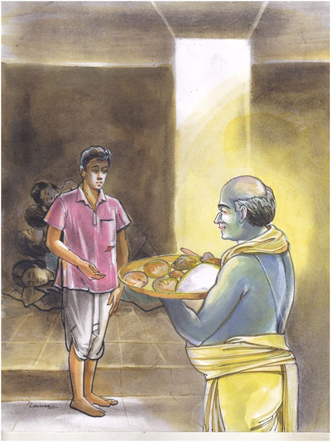 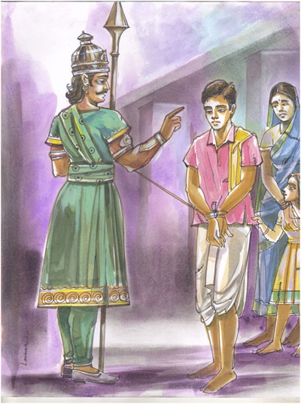

He saw a dark skinned Brahman standing Poor Bandhu tried his best to explain to the

with a big plate in his hand soldier but there was no use.

Poor Bandhu tried his best to explain to the soldier but there was no use. The soldier dragged him roughly to his superiors. There too Bandhu’s pleas fell on deaf ears. No one believed him. Everyone thought he had somehow managed to steal the thali from Ratna Bhandar and now after being caught was trying to spin a yarn in order to escape.

As he was dragged to the prison along the streets of Puri, huge crowds gathered to see the criminal who had not spared even the Lord’s Ratna Bhandar from his evil designs. People competed with each other in hurling abuses and throwing stones at the unfortunate Bandhu. He was finally thrown into prison.

His wife and children were left to suffer on their own.

In spite of he himself being subjected to immense humiliation and torture and his poor family enduring untold miseries, Bandhu’s faith in his friend Lord Jagannath did not waiver one bit. He had confidence that his bandhu would give him the courage to face every situation. He waited patiently for the Lord to save him and his family.

While Bandhu was calmly waiting for deliverance his friend Lord Jagannath, sitting on the Ratna Singhasan, was very much upset. How could his friend be made to suffer for his faith and devotion? How could he be treated so cruelly even though he was completely innocent? It was He who had taken the Mahaprasad to his friend in the gold thali. And without knowing the truth the powers that be had branded Bandhu a criminal and were subjecting him to untold torture.

That night Gajapati Pratap Rudra had a dream. Lord Jagannath had flown to his palace on his mighty Garuda. He had appeared before Gajapati and narrated the entire story about the unfortunate and innocent Bandhu Mohanty.

“A serious injustice has been done to Bandhu, my innocent friend. He and his family have suffered for no fault of theirs. He should be immediately released. All arrangements must be made so that he and his family can stay with dignity and honour.”

Gajapati got up and realising that the Lord’s instructions are to be carried out immediately, rushed to Puri. He himself went to the prison and released Bandhu. He then begged for forgiveness for all the injustice done to him.

Bandhu and family were given proper clothes to wear and taken to the Ratna Singhasan.

There in the sanctum sanctorum, standing before the Lord, Bandhu told his wife. “Meet my dearest friend, my Lord. Is he not the most powerful, wealthiest, kindest and most generous friend anyone can have? Could I have every doubted him, could I ever have questioned his love for me?”

His wife stared in amazement. ‘So Lord Jagannath himself was her husband’s friend?’ She felt ashamed that she had doubted her husband’s faith and the Lord’s benediction. She bowed her head before the Lord and sought his forgiveness.

Later Gajapati appointed Bandhu as the Kharasodha or the custodian of accounts of the temple. He arranged accommodation for Bandhu and his family at the south gate of the temple. The descendants of Bandhu continue to occupy the position of custodians of accounts to this day.

Bandhu Mohanty’s story illustrates that the Lord never deserts his true devotee. He can even leave his Ratna Singhasan to rescue his bandhu.

# Tales of Lord Jagannath: Margashira Guruvar Puja

The story of the celebration of Margashira Guruvar puja is a classic tale that espouses caste and gender equality.

## **Lord Jagannath Tales 9**

Once Goddess Lakshmi visited an area inhabited by untouchables. Lord Balabhadra was furious and convinced Lord Jagannath to banish her from the house.

Having nowhere else to go Goddess Laksmi went to Puri beach. She then requested Lord Vishwakarma, “O’ divine architect, I have been rendered homeless. Please construct a beautiful palace which would be suitable for me so that I can stay in comfort.”

The Goddess then spoke to Nidra Devi. “O’ Goddess of Sleep, I am asking you for a favour which I know is a rather strange one. Please put Lord Jagannath and Lord Balabhadra to deep slumber.”

After Nidra Devi had carried out her request Goddess Lakshmi ordered her servants to go to the abode of her husband and his elder brother and plunder it in such a way that it was left completely bare of all essentials.

The two brothers, having no other recourse, began roaming the streets, singing bhajans and begging for alms. Goddess Lakshmi requested Goddess Saraswati, “O’ Goddess of learning and wisdom cast such a spell on the people of this land that not a single soul would give alms to the divine duo. Saraswati weaved her magic and the brothers had to return empty handed from each and every house.

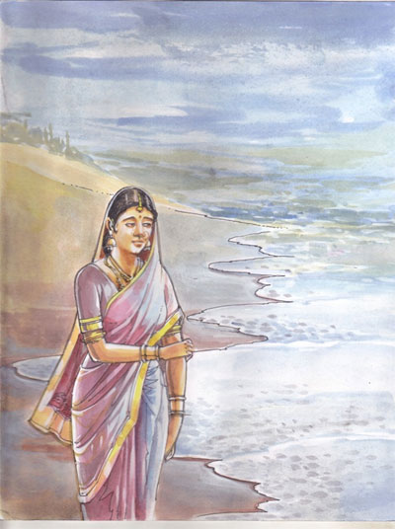 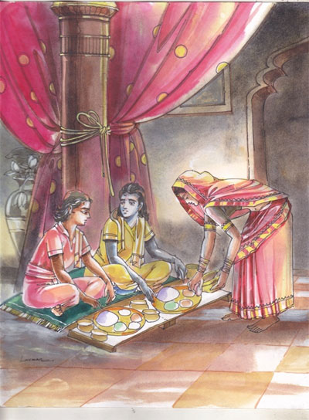

Having nowhere else to go Goddess Laksmi Desperate they went back to the palace and asked for

went to Puri beach food even if it was offered by an untouchable

At that point the siblings came to know that there was a big palace on the beach and they would get food there. They went to the palace but were told it belonged to an untouchable. They asked for provisions and vessels and decided to cook their food on the beach. Goddess Lakshmi then approached Agni Dev. “O’ God of Fire please do not light up.” Agni Dev did her bidding and as a result the two brothers could not cook.

Desperate they went back to the palace and asked for food even if it was offered by an untouchable. Goddess Lakshmi, still remaining incognito, cooked the favourite meal of Lord Balabhadra and Lord Jagannath.

Lord Jagannath, realizing that the benediction was being bestowed on him by none other than his wife, went to her. “You were right and I was wrong. Everyone should be treated equal whether man or woman, low caste or high caste. I have learnt my lesson. I hereby ordain that all devotees of mine should keep in mind this ethos of equality for all times to come.”

Lakshmi went back to her husband’s abode and happiness reigned supreme.

# Tales of Lord Jagannath: Chera Panhara, The Royal Sweeper

The tradition of Chera Panhara started by King Purushottama Deva continues to this day. It is the most famous ritual associated with the Jagannath Puri Rath Yatra. During the festival, the Gajapati King sweeps all around the deities and chariots. He then cleanses the road with a broom (gold-handled) and sprinkles sandalwood water and powder. His action bridges the gap between the rich and the poor, the low caste and the high caste and sends out the very important message of dignity of labour.

## **Lord Jagannath Tales 10**

The Jagannath Temple at Puri is one of the most magnificent and well known temples in India. It is the abode of Lord Jagannath, the Lord of the Universe, his elder brother Lord Balabhadra and their sister Devi Subhadra. There are many celebrations associated with this temple and the greatest one is the Ratha Yatra.

Every year during the month of Asadh (June-July) the divine trinity leaves the temple in three ornate chariots for a nine day sojourn to their aunt’s abode in mausi ma or Gundicha temple.  Devotees pull these chariots all the way along the bada danda or the Puri Grand Trunk Road to the Gundicha Temple. It is believed that the divine trinity blesses those who pull the chariots. This colossal spectacle is witnessed by lakhs of devotees many of who come not only from different parts of India from across the world. During the Ratha Yatra many rituals and ceremonies are performed. The story, which follows, is linked with one such ceremony.

Long ago Odisha was ruled by Gajapati Purushottama Deva of the Sun dynasty. He was a brave and noble King and a great devotee of Lord Jagannath. He would frequently say I am not the King I am merely the representative of Lord Jagannath, ruling the subjects on his behalf.”

During that period the Kingdom of Kanchi was ruled by another valiant King. He had a daughter called Padmavati who was renowned for her beauty and talent.

King Purushottama had also heard of the legendary qualities of Padmavati. He sent his ambassador to the King of Kanchi. The ambassador presented the gifts on behalf of the King and said, “O! Maharaj, my King the brave, noble and magnanimous Gajapati Purushottama Deva has sent me with a proposal.”

“Tell me what is the proposal of your King.”

“Maharaj the King has sought your daughter the beautiful Princess Padmavati’s hand in marriage.”

The King of Kanchi was delighted. He had also heard of the virtuous qualities of the ruler of Odisha. He had received many proposals for his daughter but none as attractive as this. However, before the King could give his consent one of his Ministers got up and said, “Maharaj, this proposal of marriage made by the King of Odisha cannot be acceptable to the Kingdom of Kanchi.”

“What do you mean?” the King of Kanchi asked in surprise. “What is wrong with Purushottama Deva? Haven’t we all heard tales of his valour?”

“Maharaj, the King of Odisha is no doubt a brave and just ruler. He is loved by his subjects. However, once a year he does the work of a sweeper. Tell me can the Kingdom of Kanchi accept the proposal for its Princess from such an individual even if he happens to be a King?”

“What!  I don’t believe this?”  the King exclaimed and then turning to the ambassador asked, “Tell me, is this true?”

“Maharaj, on the day of Rath Yatra, the Car Festival, the King performs a special ceremony called Chera Pahara. As a part of this ritual the King sweeps the floors of the chariots, which carry the images of Lord Jagannath, Lord Balabhadra and Devi Subhadra. This ceremony stresses on the dignity of labour. There is no task, which is low or high in the eyes of the Lord, and the King by performing Chera Pahara seeks to emphasise this value. My King feels it is a great honour to perform this task and is proud to carry it out.”

“Don’t talk nonsense. No logic can justify your King’s lowly actions. Go and tell him that I refuse to give Padmavati’s hand in marriage to a man who is nothing but a sweeper. You can also tell him that he has insulted me by daring to even consider himself suitable as a husband for my daughter. And if you had not been an ambassador merely carrying out your impudent King’s instructions I would have beheaded you for bringing such an insolent proposal. ”

When the ambassador went back and recounted to Purshottama Deva his experience at Kanchi, the King was livid with anger.

“I shall have to avenge this insult. I’ll attack Kanchi, capture the Princess and get her married to a real sweeper. That will teach the haughty King of Kanchi a lesson he will never forget,” he declared.

In the first offensive on Kanchi, the army of Purushottam Deva was defeated. The King waited for a year and then decided to launch another attack. Before his campaign he went to the temple of Lord Jagannath and prayed. He invoked the blessings of the Lord in vanquishing the arrogant King of Kanchi who had insulted Chaka Aakhi  himself. This time Purushottama Deva himself  led his soldiers.

The King had not travelled far from Puri when he was stopped by a young woman.

“Who are you and what do you want?” the King asked.

“My name is Manika, I am a milk maid.  Two men passed this way a few hours ago. One was fair and the other was dark. One was riding a white horse and the other a black one. They were handsome and looked of royal lineage. They very gently asked me for some curd. After they had eaten the curd I asked them for money. They started searching their belongings but found that they did not have any money. Then the one who was dark took out a diamond ring and told me, ‘A King, leading a huge army, will follow us shortly. You take this ring to him and he will pay you the cost of the curd.’   The two handsome strangers then galloped away on their horses,” with these words Manika gave the King a diamond ring.

The King looked at the diamond ring and was amazed. He could not believe his eyes. In his palm was the diamond ring of Lord Jagannath himself! Just then a messenger came rushing from the Jagannath Temple at Puri. He informed the King that the diamond ring, which adorned the finger of Lord Jagannath, was missing.

Purushottama Deva was elated. Lord Jagannath and Lord Balabhadra had personally joined his campaign against the conceited King of Kanchi. The King bowed in devotion to the Gods and informed his soldiers of their good fortune.

He paid Manika the cost of the curd and named the village she came from after her. To this day the village is called Manikapatna.

The King and his army set forth to Kanchi with renewed confidence. They were now sure with Lord Jagannath and Lord Balabhadra on their side no army could vanquish them.

In the war Purushottoma Deva’s soldiers fought like never before and trounced the King of Kanchi’s army.

Purushottoma Deva imprisoned Padmavati and brought her to Puri. He called his Minster and issued instructions, “Her father insulted me and my devotion to Lord Jagannath. Take her away and get her married to a sweeper.”

The Minister was an old man with a wise head on his shoulders. He took the Princess home and took care of her as his own daughter.

Months went by. At the next Ratha Yatra the King, as was the custom, swept the floor of the three chariots. After the ritual, as he stepped down from the third chariot, the Minister came up to the King. Behind him was standing Princess Padmavati.

The Minister bowed and addressed the King, “Maharaj you asked me to marry Princess Padmavati to a sweeper. Well I searched far and wide but could not find a more suitable sweeper than you. So please accept her hand in marriage and help me in carrying out your instructions.”

The King looked at Princess how was looking more enchanting than ever before. He had always loved her, but his ego had come in between. Now he brushed aside his anger and pride and accepted the hand of Padmavati in marriage.

The tradition started by King Purushottama Deva continues to this day. The Raja of Puri, even now sweeps the floor of the chariots and in this way pays his tribute to the Lord and the credo of dignity of labour.

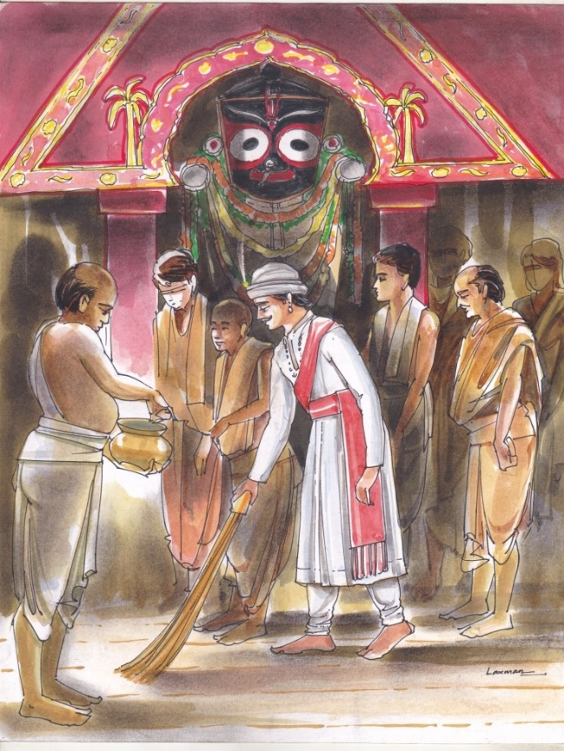 The King performs a special ceremony called Chera Pahara. As a part of this ritual the King sweeps the floors of the chariots, which carry the images of Lord Jagannath, Lord Balabhadra and Devi Subhadra.

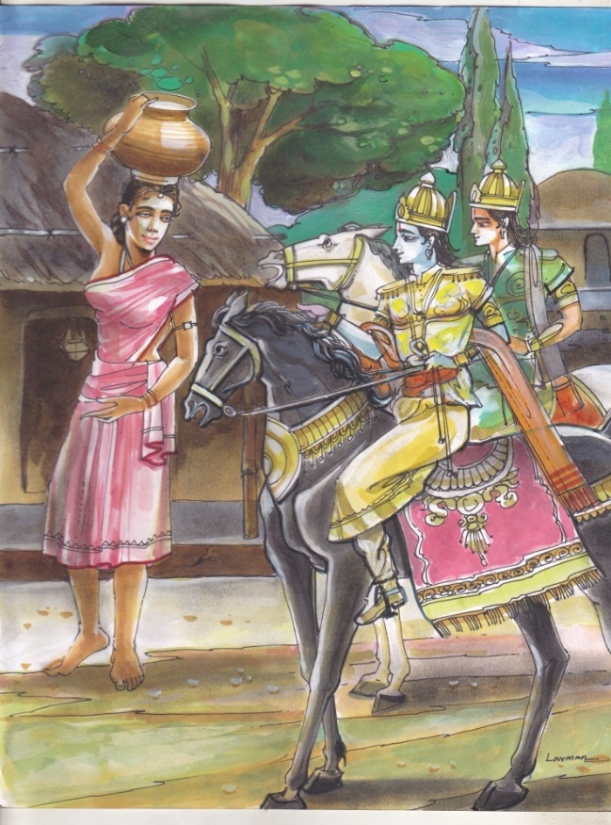 My name is Manika, I am a milk maid

[About the Author](https://learningandcreativity.com/ramendrakumar/)

[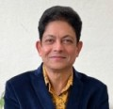](https://learningandcreativity.com/ramendrakumar/)

[**Ramendra Kumar**](https://learningandcreativity.com/ramendrakumar/)([117 Posts](https://learningandcreativity.com/ramendrakumar/))

Ramendra Kumar (Ramen) is an award-winning writer, performance storyteller and inspirational speaker with 49 books. His writings have been translated into 32 languages and included in 26 textbooks and many anthologies in various countries. Ramen has written across all genres ranging from picture books to adult fiction, satire, poetry, travelogues, biographies and on issues related to parenting and relationships. His writings have been published by the major publishing houses in India. His books brought out by National Book Trust (NBT), India have notched up sales of more than 4.9 lakh copies in just one year. Ramen has been invited to several international literary festivals as well as Indian events such as Jaipur Litfest and seminars organised by Sahitya Akademi and IGNOU. The author has won a total of 41 awards in the competition for writers of children’s literature organised by Children’s Book Trust (CBT) over the years, which is among the highest by any writer. Ramen was chosen as the ‘Author and Storyteller of the Year’ (2022), on ‘Talking Stories’, London, UK’s number one Radio Programme dedicated to the art of storytelling. He was nominated as a Jury Member for the Best Children’s Author Category of The Times of India’s ‘Women AutHer’ Awards, 2020. Ramen was also selected as a mentor for the Scholastic Writers Academy. An alumnus of the prestigious Hyderabad Public School (HPS), Ramen is an Engineer & an MBA. He and his inspiration, his wife Madhavi, were General Managers at SAIL, when they took Voluntary Retirement to pursue their respective passions. Their children are bonsai celebrities in their own right. While Ankita is a youth icon and a travel blogger with an Instagram following of 296 K, Aniket creates cool Apps and designs covers for his dad’s books. Ramen is now a Cancer warrior and an inspiration to many. His website is www.ramendra.in and he has a page devoted to him on Wikipedia.